**MINI PROJECT – II REPORT**

ON

**“RADAR USING ULTRASONIC SENSOR”**

*A Mini Project- II report submitted in partial fulfillment of the requirement for the award of Degree of*

**Bachelor of Technology**

(Sixth Semester)

**In**

**COMPUTER SCIENCE & ENGINEERING**

Session 2022-2023

**Prescribed By**

*DBATU University, Lonere*



**Guided By Submitted By**

**Dr. Bireshwar Ganguly Achal Ragit (CSEC603) Gudiya Prasad (CSEC611)**

**Sneha Wankar (CSEC640)**

**Achal Waghmare (CSEC602)**

**Shurtika Umare (CSEC637)**

DEPARTMENT OF COMPUTER SCIENCE & ENGINEERING

RAJIV GANDHI COLLEGE OF ENGINEERING

RESEARCH & TECHNOLOGY,

CHANDRAPUR.

Session 2022-2023

**CERTIFICATE**

This is to certify that, Ms. **Achal Ragit (CSEC603)**,

Ms. **Gudiya Prasad (CSEC611)**, Ms. **Sneha Wankar (CSEC640)** Ms. **Achal Waghmare (CSEC602)** And Ms. **Shurtika Umare (CSEC637)** Studying in Sixth Semester Department of COMPUTER SCIENCE & ENGINEERING,

have completed the Mini project - II

“**RADAR USING ULTRASONIC SENSOR**”

satisfactorily during the Academic Session 2022-2023 from Rajiv Gandhi College of Engineering Research & Technology, Chandrapur.

Mini-Project Guide Mini-Project incharge

(Prof.Dr. Bireshwar Ganguly) (Prof. Madhavi Sadu )

Dr. Nitin Janwe

H.O.D.

CSE RCERT, Chandrapur

**Rajiv Gandhi College of Engineering Research & Technology, Chandrapur**

**Department of Computer Science & Engineering**

**Institute Vision**

To be on forefront to impart quality education to address societal and industrial needs and imbibe career skills through perseverance and practice.

**Institute Mission**

**M1**. To adapt innovative student centric learning methods based on

understanding and practice.

**M2** .To enhance professional and entrepreneurial skills.

**M3**.To motivate students to meet dynamic needs of the society with novelty and

creativity.

**M4**.To promote research and continuing education to keep the country ahead.

**M5**.To promote the mindset to acquire local solutions to local problems

(LS2LP).

**Department Vision**

To be a centre of excellence in Computer Science & Engineering by imparting knowledge, professional skills and human values.

**Department Mission**

**M1**. To create encouraging learning environment by adapting innovative student centric learning methods promoting quality education and research.

**M2**. To make students competent professionals and entrepreneurs by imparting career skills and ethics.

**M3**. To impart quality industry oriented education through industrial internships, industrial projects and partnering with industries to make students corporate ready.

Rajiv Gandhi College of Engineering Research & Technology, Chandrapur

**Department of Computer Science & Engineering**

**Program Educational Objectives**

**PEO1:** Impart quality industry oriented education, strong fundamentals and problem solving approach through student centric learning methods for product development and handle real time problems.

**PEO2:** Possess good communication skills and ethics in line with corporate environments to serve the industry & society.

**PEO3:** Create Competent Professionals & entrepreneurs by imparting Career skills, leadership qualities and research

**Program Specific Outcomes:**

**PSO1:** **Foundation of Computer System:** Ability to understand the principles and working of computer systems. Students can assess the hardware and software aspects of computer systems.

**PSO2:** **Foundations of Software development:** Ability to understand the structure and development methodologies of software systems. Possess professional skills and knowledge of software design process. Familiarity and practical competence with a range of programming languages and platforms like Cloud Computing, Web based and Mobile applications, Image and Video Processing, Artificial Intelligence & Machine Learning.

**PSO3:** **Foundation of mathematical concepts:** Ability to apply mathematical methodologies to solve computational tasks, model real world problems using appropriate data structures and suitable algorithms.

Rajiv Gandhi College of Engineering Research & Technology, Chandrapur

**Department of Computer Science & Engineering**

Project Title: **RADAR USING ULTRASONIC SENSOR**

**Project PO/ PSO Attainment**

|  |  |  |
| --- | --- | --- |
| PO/PSO | Attainment  (level1=low,2= moderate,3=High) | Description |
| PO1 | **3** | In this project work, engineering knowledge is applied at highest level. |
| PO2 | **3** | In this project work, Problem analysis is done at highest level. |
| PO3 | **3** | In this project work, Design/Development of Solutions is applied at highest level. |
| PO4 | **3** | In this project work, conduction of investigations of complex problem is done at highest level. |
| PO5 | **3** | In this project work, modern tool usuage is applied at highest level. |
| PO6 | **3** | In this project work, the engineer and society concept is applied at highest level. |
| PO7 | **3** | In this project work, the engineer and society concept is applied at moderate level. |
| PO8 | **1** | In this project work, Ethics exists at lowest level. |
| PO9 | **3** | In this project work, Individual and teamwork exists at highest level. |
| PO10 | **3** | In this project work, Communication exists at highest level. |
| PO11 | **3** | In this project work, Project management and finance exists at moderate level. |
| PO12 | **3** | In this project work, Life Long Learning exists at highest level. |
| PSO1 | **3** | In this project work, Foundation of computer System exists at highest level. |
| PSO2 | **3** | In this project work, Foundation of Software Development exists at highest level. |
| PSO3 | **3** | In this project work, Foundation of mathematical concepts exists at highest level. |

**Signature of Project Guide**

**ACKNOWLEDGEMENT**

At first, we would like to express our sincere thanks to Rajiv Gandhi College of engineering research and technology and teachers relating to the mini project committee for giving us the opportunity to work in a mini project which will be fruitful for the upcoming days.

Secondly, we would also like to thank our honorable HOD Dr. Nitin Janwe , respected Prof. Dr. Bireshwar Ganguly and others teachers who have been a great help in this mini project whether it be guidance for the betterment of the mini project or be the different approaches we could take to make this mini project better than the initial project than we had in mind.

At last, we would like to thank all the teachers who have been a help in this mini project as this mini project would not have been completed without the guidance of the teachers who have been a great support throughout the duration of this mini project.

***ABSTRACT***

Radar is an object detection system which uses radio waves to determine the range, direction of objects. The radar dish or antenna transmits pulses of radio waves or microwaves which bounce off any object in their path. Arduino is a single-board microcontroller to make using electronics in multidisciplinary projects more accessible. This project aims at making a Radar that is efficient, cheaper and reflects all the possible techniques that a radar consists of.

The proposed system "ultrasonic radar for the object detection distance and the speed measurement” employs an ultrasonic module that includes an ultrasonic transmitter and receiver. It operated by transmitting 40 kHz frequency pulse which is not audible to the human ear.

Module rotate with step angle of the stepper motor with specific angle for a specific time interval and the distance between the object and system is measured by calculating time interval taken by the signal to transmit and the echo reception Whereas the detected signal is shifted toward the module or away from the module which give the information about the speed of that detected object which is shown on PPI Display.

**CONTENT**

|  |  |
| --- | --- |
| 1 | INTRODUCTION |
| 2 | SYSTEM REQUIREMENTS   * Software requirements * Hardware description |
| 3 | ARCHITECTURE OF PROJECT |
| 4 | MODULES DEVELOPED |
| 5 | GRAPHICAL USER INTERFACE |
| 6 | WORKING |
| 7 | SOURCE CODE |
| 8 | OUTPUT |
| 9 | DATABASE |
| 10 | ADVANTAGE & DISADVANTAGE |
| 11 | PAPER PUBLISHED AND CERTIFICATE |
| 12 | CONCLUSION |
| 13 | REFERENCE |

**INTRODUCTION**

Radar is an object detection system which uses radio waves to determine the range OR direction of objects. Radar systems come in a variety of sizes and have different performance specifications. Some radar systems are used for air-traffic control at airports and others are used for long range surveillance and early-warning systems. A radar system is the heart of a missile guidance system. Small portable radar systems that can be maintained and operated by one person are available as well as systems that occupy several large rooms.

Radar was secretly developed by several nations before and during World War II. The term Radar itself, not the actual development, was coined in 1940 by the United States Navy as anacronym for radio Detection and Ranging. The term radar has since entered English and other languages as the common noun radar, losing all capitalization.

The modern uses of radar are highly diverse, including air traffic control, astronomy, air, antimissile systems; marine radars to locate landmarks and other ships: aircraft anti-collision systems; ocean surveillance systems, outer space surveillance and rendezvous systems; meteorological precipitation monitoring; altimetry and flight control systems; guided missile target locating systems; and ground-penetrating radar for geological observations. High tech radar systems are associated with digital signal processing and are capable of extracting useful information from very high noise levels.

**SYSTEM REQUIREMENTS**

* **SOFTWARE REQUIREMENTS**

1. Arduino IDE
2. Processing Application

* **HARDWARE DESCRIPTION**

1. **ULTRASONIC SENSOR**

An ultrasonic sensor works similar as of sonar. It can measure distance of object by sending sound waves. Sound waves are send at a specific frequency at a specific direction and listen for sound wave to come back. time taken by sound wave to come back helps us to determine distance of object.

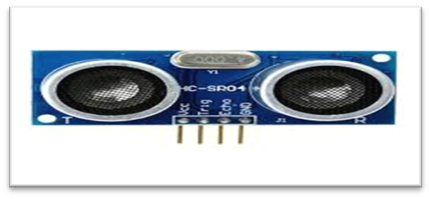

2. **SERVO MOTOR**

A servomotor is a rotary actuator that allows for precise control of angular position, velocity and acceleration. It consists of a suitable motor coupled to a sensor for position feedback. It also requires a relatively sophisticated controller, often a dedicated module designed specifically for use with servo motors. Servomotors are not a different class of motor, on the basis of fundamental operating principle, but uses servomechanism to achieve closed loop control with a generic open loop motor. Servomotors are used in applications such as robotics, CNC machinery or automated manufacturing.

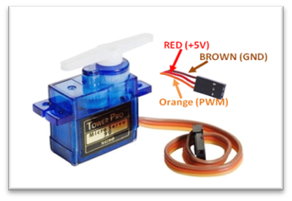

3. **ARDUINO**

The Arduino is an open source electronics platform based on easy to use hardware and software. The open source Arduino software makes it easy to write code and upload it to the board. It runs on Windows, Mac OS X and Linux. The environment is written in java and based on processing and other open source software. This software can be used with any Arduino board. The Arduino software IDE contains a text editor for writing code, a message area, a text console, a toolbar with buttons for common function. It connects to Arduino and Genuino hardware t+o upload programs and communicate with them. Program written using Arduino software are called sketches.

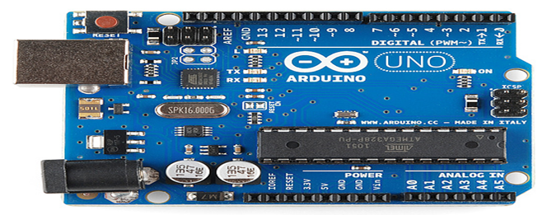

4. **BREADBOARD**

Breadboards are one of the most fundamental pieces when learning how to build circuits. In this tutorial, you will learn a little bit about what breadboards are, why they are called breadboards, and how to use one. Once you are done you should have a basic understanding of how breadboards work and be able to build a basic circuit on a breadboard.

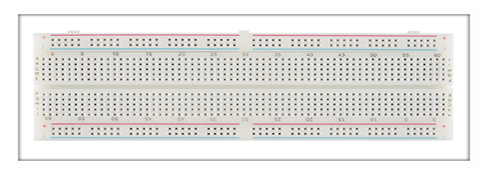

5. **JUMPER WIRES**

Jumper wires are simply wires that have connector pins at each end, allowing them to be used to connect two points to each other without soldering. Jumper wires are typically used with breadboards and other prototyping tools in order to make it easy to change a circuit as needed .

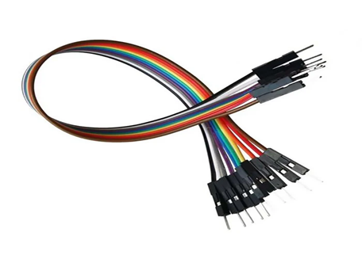

**ARCHITECTURE OF PROJECT**

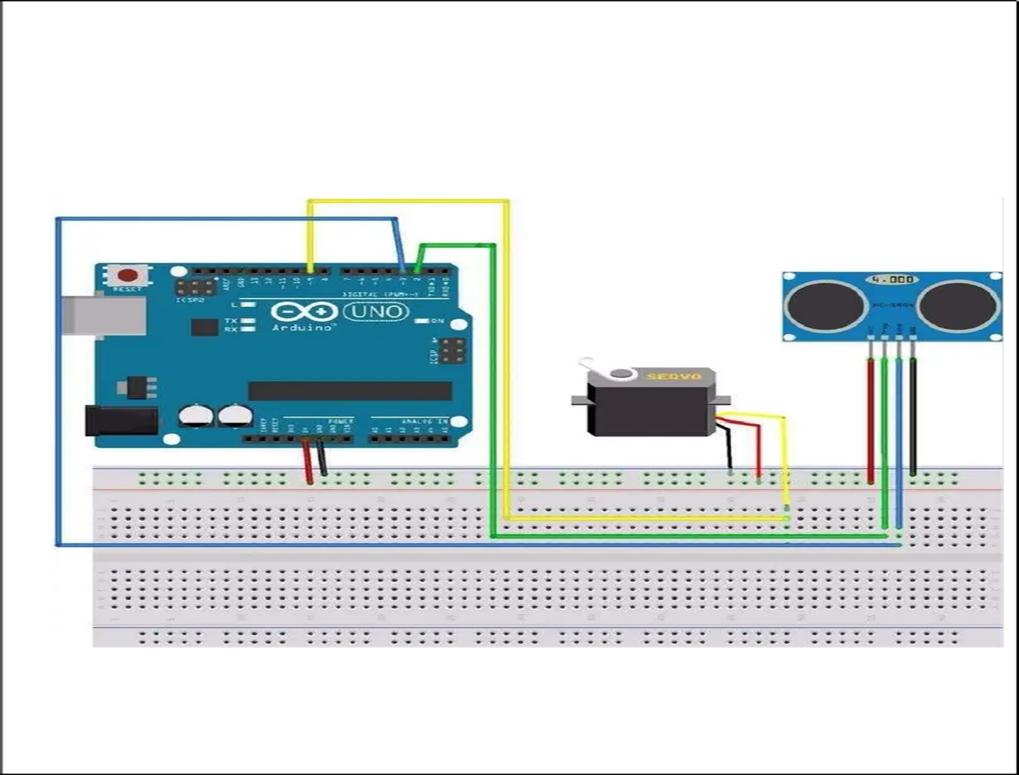

**MODULES DEVELOPED**

**TABLE**

**Accuracy Measurement Of Direction Or Angle (Degree)**

|  |  |  |
| --- | --- | --- |
| Actual direction (degree) | Servo indicated directed (degree) | Efficiency(%) |
| 10 | 23 | 98.70% |
| 40 | 53 | 99.68% |
| 50 | 59 | 99.82% |
| 85 | 86 | 99.99% |
| 95 | 90 | 100% |
| 110 | 109 | 100% |
| 130 | 129 | 100% |
| 150 | 150 | 100% |
| 165 | 165 | 100% |

**GRAPHICAL USER INTERFACE**

GUI was build in JAVA program language and it has 2 classes that are given in below diagram in figure.

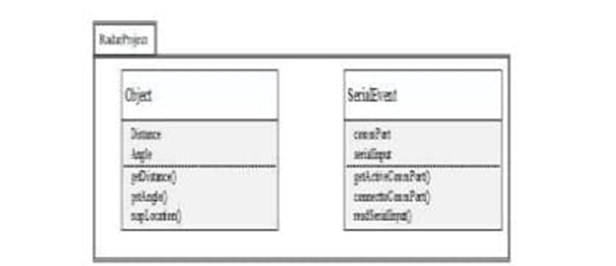

**Figure. UML Class Diagram for GUI sub-system.**

© 2018 IJNRD | Volume 3, Issue 4 April 2018 | ISSN: 2456-4184 1

UML Class Diagram for GUI sub-sy Object class of radar project represent object that it encounters such as distance, target/range and angle/direction of position of object.

* Distance method (), angle () method, location () method takes the required value such as distance, angle and makes them on GUI to do simulation.

Figure shows line sweep from one-direction to other and a smudge is made is GUI where ultrasonic sensor sense obstacles

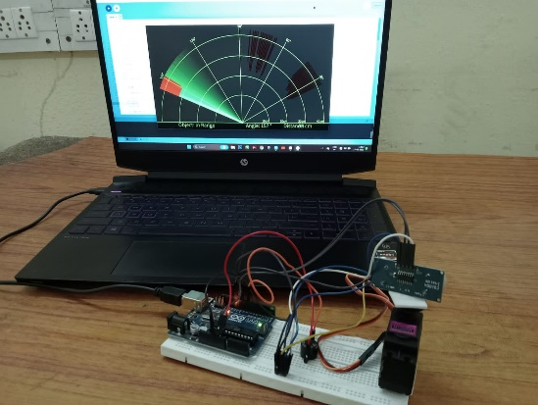

**WORKING**

The ultrasonic sensor scans for objects within its range for detection with the help of a servo motor. Here, in the setup, our ultrasonic sensor’s proximity is set as 40 cm and the angle of detection is set as 120 degrees. When an object is detected in the range of the ultrasonic sensor, the distance, and angle at which the object is detected are recorded and transmitted to the turret’s servo motor and the PC via serial ports. The turret’s servo motor turns to the angle at which the object is detected. Meanwhile when an object is detected the buzzer rings and LEDs light up which makes up the alert system for the user. The serial ports from the microcontroller to the PC send the angle and distance at which the object is detected. This is plotted on the screen which mimics the actual radar system.

The ultrasonic sensor rotates with the servo motor and transmitted the ultrasonic waves during this time. and the whole time a graph interface make in the simulation software. and if any object comes under the range of the ultrasonic sensor it starts to detect the object. at that time the graph interface inside the software becomes red in the object area. ultrasonic sensor work as an object detector in this project. Radar using ultrasonic sensor works in software makes the reaction according to the waves received.

ultrasonic sensors have two terminals one is a transmitter and another is the receiver. The transmitter terminal is known as the Trigger and the receiver terminal is known as the echo. Arduino continuously gives a command to the Servo motor to rotate. and the transmitter transmits the signal parallelly likewise the software also makes the graph. The ultrasonic sensor gave a different signal to the Arduino if anything comes in the path. then Arduino notifies the software for the affected region. the project depends on the ultrasonic sensor working. Radar using Arduino, ultrasonic sensor, and servo motor contents no other major components**.**

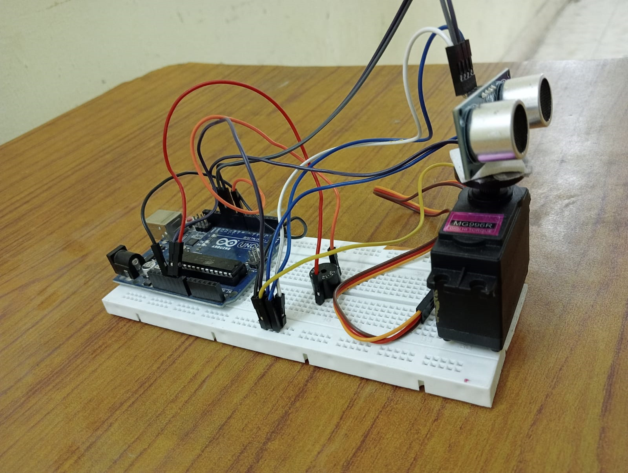

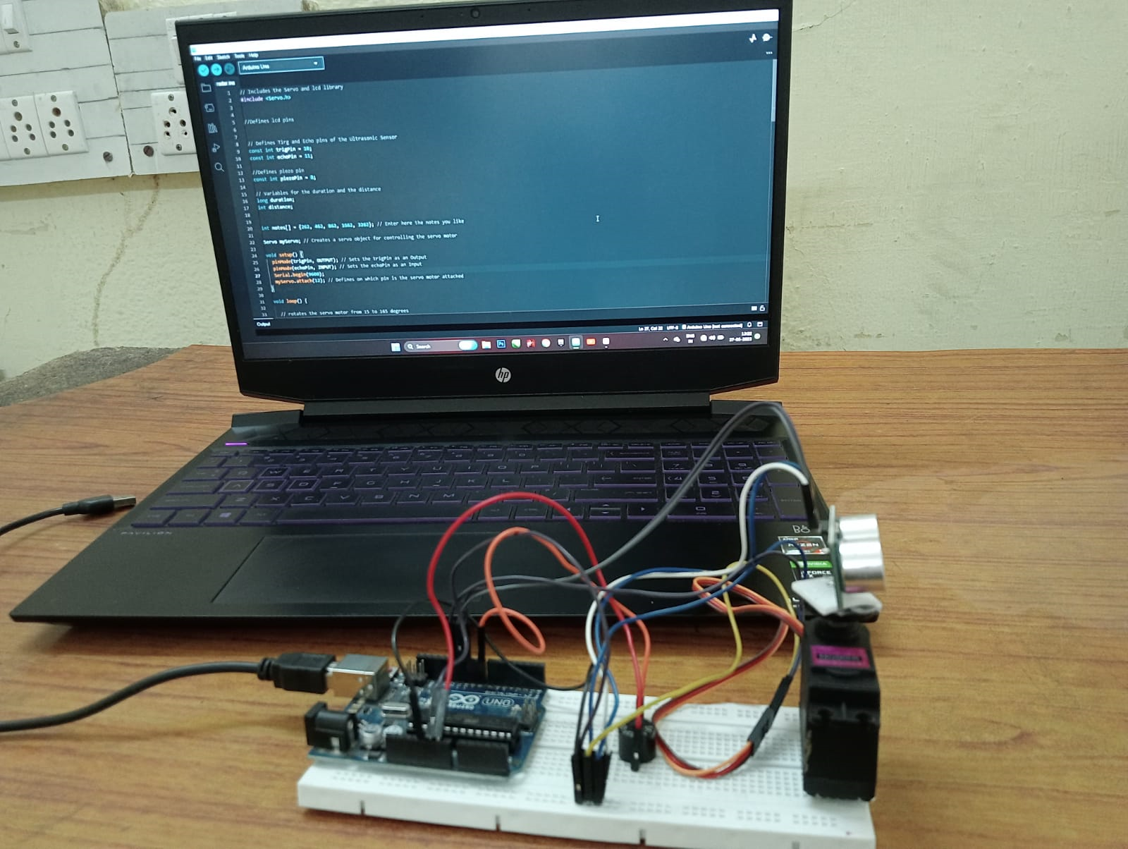

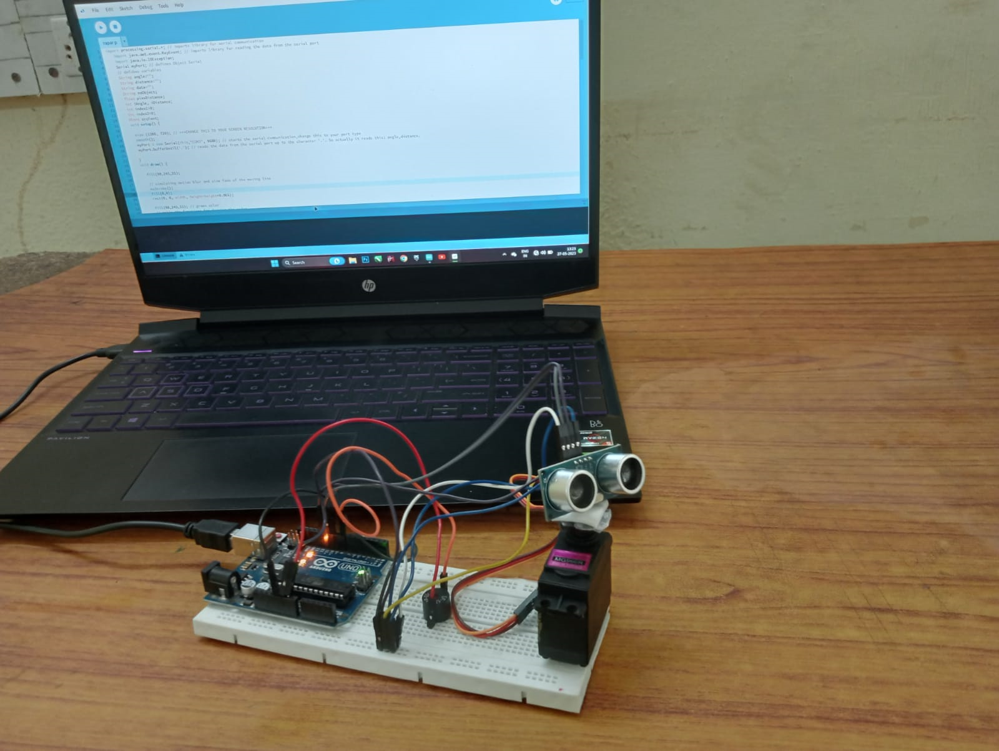

**SOURCE CODE**

* **Arduino Software Code**

#include <Servo.h>

//defines lcd pins

//defines tirg and echo pins of the ultrasonic sensor

Const int trigpin – 10;

Const int echopin – 11;

//defines piezo pin

Const int piezoin - 8;

//variables for the duration and the distance

Long duration;

Int distance;

Int notes[] – { 262, 462, 862, 1662, 3262}; //enter here the notes you like

Servo myservo; // creates a servo object for controlling the servo motor

Void setup() {

Pinmode (trigpin, OUTPUT); //sets the trigpin as an output

Pinmode (echopin, INPUT); // sets the echopin as an input

Serial.begin(9600);

Myservo.attach(12); // defines on which pin is the servo motor attached

}

Void loop(){

// rotates the servo motor from 15 to 165 degrees

For(int i-15; 1<-165; i++){

Myservo.write(i);

Distance – calculatedistance(); // calls a function for calculating the distance measured by the ultrasonic sensor for each degree

//beep sequence

If(distance > 40){

noTone(piezopin);

delay(10);

noTone(piezopin);

delay(30);

}

Else if (distance < -40 && distance >30){

Tone(piezopin, notes[1]);

Delay(10);

noTone(piezopin);

delay(30);

}

Else if (distance <-30 && distance > 20){

Tone (piezopin, notes[20]);

noTone(piezopin);

delay(30);

}

Else{

Tone(piezopin,notes[4]);

Delay(10);

noTone(piezopin);

delay(30);

}

Serial.print(i);//sends the current degree into the serial port

Serial.print(“,”);//sends addition character right next to the previous value needed

later in the processing IDE for indexing

serial.print(distance);//sends the distance value into the serial port

serial.print(“,”);//sends addition character right next to the previous value needed

later in the processing IDE for indexing

}

//repeats the previous lines from 165 to 15 degrees

For(int i-165; i>15; i--){

Myservo.write(i);

Distance – calculatedistance();

If(distance > 40){

NoTone(piezopin);

Delay(10);

noTone(piezopin);

delay(30);

}

Else if (distance <-40 && distance >30){

Tone (piezopin, notes[1]);

Delay(10);

Notone(piezopin);

Delay(30);

}

Else if (distance <-30 && distance >20){

Tone (piezopin, notes[2]);

Delay(10);

Notone(piezopin);

Delay(30);

}

Else if (distance <-20 && distance >10){

Tone (piezopin, notes[3]);

Delay(10);

Notone(piezopin);

Delay(30);

}

Else{

Tone (piezopin, notes[4]);

Delay(10);

Notone(piezopin);

Delay(30);

}

Serial.print(1);

Delay(30);

}

Else if (distance <-40 && distance >30){

Tone (piezopin, notes[1]);

Delay(10);

Notone(piezopin);

Delay(30);

}

Else if (distance <-30 && distance >20){

Tone (piezopin, notes[2]);

Delay(10);

Notone(piezopin);

Delay(30);

}

Else if (distance <-20 && distance >10){

Tone (piezopin, notes[3]);

Delay(10);

Notone(piezopin);

Delay(30);

}

Else{

Tone (piezopin, notes[4]);

Delay(10);

Notone(piezopin);

Delay(30);

}

Serial.print(i);

Serial.print(“,”);

Serial.print(distance);

Serial.print(“,”),

}

}

//function for calculating the distance measured by the ultrasonic sensor

Int calculatedistance(){

Digitalwrite(trigpin, LOW);

Delaymicroseconds(2);

//sets the trigpin on HIGH state for 10 micro seconds

Digitalwrite(trigpin,HIGH);

Delaymicroseconds(10);

Digitalwrite(trigpin, LOW);

Duration – pulseIN(echopin,HIGH);

//U(m/s)-dx(m)/(m)/dT(s)

//in this case duration(time)- 2*distance/speed of sound->

//distance-speed of sound * duration/2

// in dry air at 200 c, the speed of sound is 343.2 m/s or 0.003432 m/microsecond

Or 0,03434 cm/microseconds

Distance – duration*0.034/2;

Return distance;

}

* **Processing Software Code**

Import processing.serial, *; //imports library for serial communication

Import java.awt.event.keyevent; //import library for reading the data from the

Serial port

Import java.io.IDException;

Serial myport; // defines object serial

// defubes variables

String angle “”;

String distance “”;

String data “”;

String noobject;

Float pixdistance;

Int iAngle, iDistance;

Int index1-0;

Int index2-0;

PFont orcFont;

Void setup() {

Size (1280,720); //***CHANGE THIS TO YOUR SCREEN RESOUTION***

Smooth();

Myport – new serial(this, “COM3”, 9600); //starts the serial communication,

Change this to your port type

Myport.bufferunit(‘,’);// reads the data from the serial port up to the character ‘,’.

So actually it reads this: angle, distance.

}

Void draw(){

Fill(98,245,31);

//simulating motion blur and slow fade of the moving line

Nostroke();

Fill(0,4);

Rect(0,0, width, height- height*0.065);

Fill(98,245,31);//green color

//calls the function for drawing the radar

Drawradar();

Drawline();

Drewobject();

Drawtext();

}

Void serialevent (serial myport){// starts reading data from the serial port

//reads the data from the serial port up to the character ‘,’ and put it into the string variable “data”.

Data- myport.readstringuntil(‘,’);

Data- data.substring(0, data.length()-1);

Index – data.indexof(“,”);//find the character ‘,’ and puts it into the variable “index1”

Angle- data.substring(0,index1);// read the data from postion “0” to position of the variable index1 or that the value of the angle the Arduino board sent into the serial port

Distance – data.substring(index1+1,data.length());//read the data from poition “index1” to the end the data pr that value of the distance

//convert the string variables into integer

iAngle – int(angle);

iDistance – int(distance);

}

Void drawradar(){

Pushmatrix();

iAngle – int(angle);

iDistance – int(distance);

}

Void drawradar() {

Pushmatrix();

Translate(width/2, height-height*0.074);// moves the starting to new location

noFill();

strokeweight(2);

stroke (98,245,31);

//draws the arc lines

Arc(0,0,(width-width*0.0625),(width-width*0.0625),PI,TWO_PI);

Arc(0,0,(width-width*0.27),(width-width*0.27),PI,TWO_PI);

Arc(0,0,(width-width*0.479),(width-width*0.479),PI,TWO_PI);

Arc(0,0,(width-width*0.687),(width-width*0.687),PI,TWO_PI);

//draws the angle lines

Line(-width/2, 0, width/2, 0);

Line(0,0,(-width/2)*cos(radians(30)),(-width/2)*sin(radians(30)));

Line(0,0,(-width/2)*cos(radians(60)),(-width/2)*sin(radians(60)));

Line(0,0,(-width/2)*cos(radians(90)),(-width/2)*sin(radians(90)));

Line(0,0,(-width/2)*cos(radians(120)),(-width/2)*sin(radians(120)));

Line(0,0,(-width/2)*cos(radians(150)),(-width/2)*sin(radians(150)));

Line((-width/2)*cos(radians(30)),0, width/2,0);

Popmatrix();

}

Void drawobject(){

Pushmatrix():

Translate(width/2,height-height*0.074);//moves the starting coordinates to new location

//limiting the range to 40 cms

If(iDistance<40){

//draws the object according to the angle and the distance

Line(pixsDistance*cos(radians(angle)),-pixsDistance*sin(radians(iAangle)), (width-width*0.505)*cos(radians(iAngle)), -(width-width*0.505)*sin

(radians(iAangle)));

}

Popmatrix();

}

Void drawline(){

Pushmatrix();

Strokeweight(9);

Stroke(30,250,60);

Translate(width/2,height-height*0.074);//moves the starting coordinates to new location

Line(0,0(height-height*0.12)*cos(radians(iAangle)),-(height-height*0.12)

*sin(radians(iAngle))); // draws the line according to the angle

Popmartix();

}

Void drawtext(){//draws the texts on the screen

Pushmatrix();

If(iDistance>40){

Noobject-“Out Of Range”;

}

Else{

Noobject – “In Range”;

Translated(width/2,height-height*0.074);// moves the starting coordinates to new location

Line(0,0(height-height*0.12)*cos(radians(iAangle)),-(height-height*0.12)

*sin(radians(iAngle))); // draws the line according to the angle

Popmartix();

}

Void drawtext() {// draws the texts on the screen

Pushmatrix();

If(iDistance>40){

noObject –“Out Of Range”;

}

Else{

noObject –“In Range”;

}

Fill(0,0,0);

Nostroke();

Rect(0, height-height*0.0648, width, height);

Fill(98,245,31);

Textsize(25);

Text(“10cm”, width-width*0.3854, height-height*0.0833);

Text(“20cm”, width-width*0.281, height-height*0.0833);

Text(“30cm”, width-width*0.177, height-height*0.0833);

Text(“40cm”, width-width*0.0729, height-height*0.0833);

Textsize(40);

Text(“object:” +noobject, width- width*0.875,height-height*0.0277);

Text(“angle:” +iangle +”0”, width- width*0.48,height-height*0.0277);

Text(“distance:”, width- width*0.26,height-height*0.0277);

If(iDistance<40){

Text(“ ” +iDistance+ “cm” width- width*0.225,height-height*0.0277);

}

Textsize(25);

Fill(98,245,60);

Translate((width-width*0.4994)+width/2*cos(radians(30)),(height-height

*0.0907 ) -width/2*sin(radians (30)));

Rotate(-radians(-60));

Text(“300”, 0,0);

Resetmatrix();

Translate((width-width*0.503)+width/2*cos(radians(60)),(height-height

*0.0888 ) -width/2*sin(radians (60)));

Rotate(-radians(-30));

Text(“600”, 0,0);

Resetmatrix();

Translate((width-width*0.507)+width/2*cos(radians(90)),(height-height

*0.0833 ) -width/2*sin(radians (90)));

Rotate(-radians(0));

Text(“900”, 0,0);

Resetmatrix();

Translate((width-width*0.513)+width/2*cos(radians(120)),(height-height

*0.07129 ) -width/2*sin(radians (120)));

Rotate(-radians(-30));

Text(“120”, 0,0);

Resetmatrix();

Translate((width-width*0.5104)+width/2*cos(radians(150)),(height-height

*0.0574 ) -width/2*sin(radians (150)));

Rotate(-radians(-60));

Text(“150”, 0,0);

popmatrix();

}

**OUTPUT**

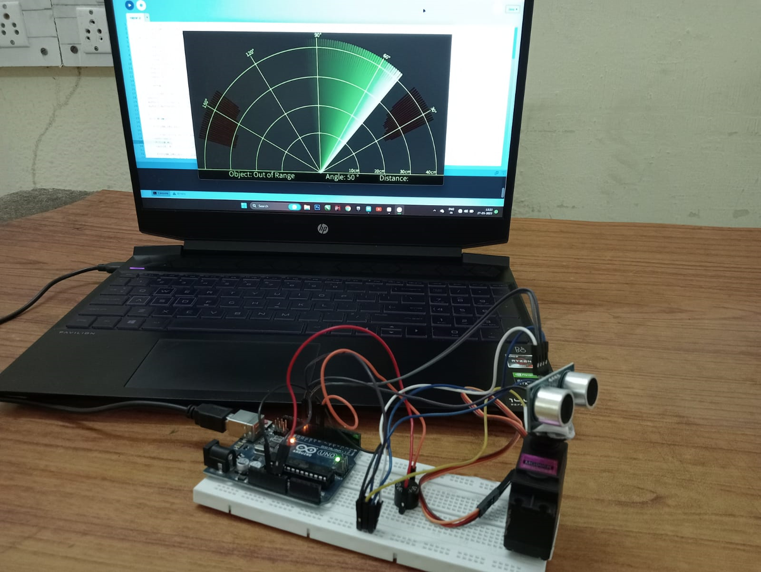

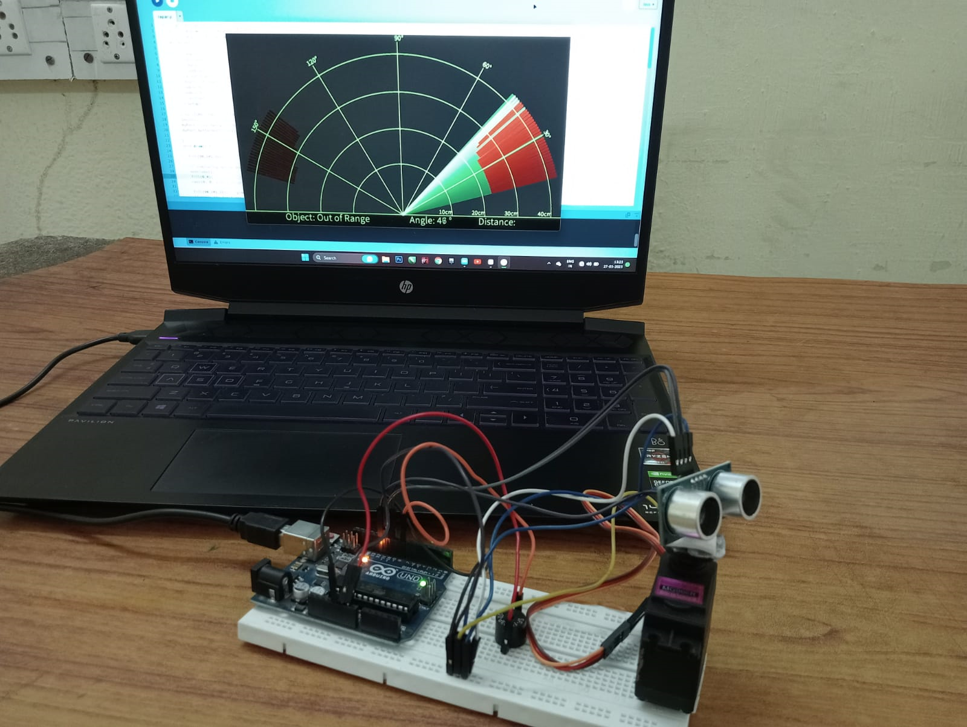

**DATABASE**

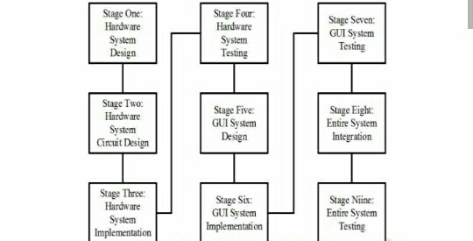 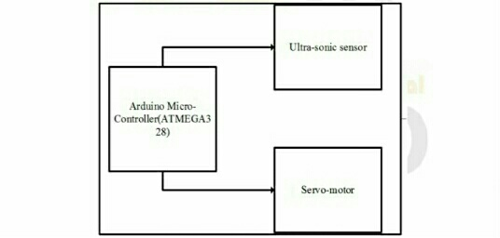

**ADVANTAGES**

1. It is not affected by colour or transparency. Basically, the Ultrasonic Sensors transmit the sound off of the object, hence the colour and transparency have no effect on the radar reading.

2. Any dark environments have no effect on this Arduino radar sensor’s detection procedure. So, it can also use at night.

3. Easy to design and low price. The ultrasonic sensors are available at the market with very cheap price.

4. It has high frequency, high sensitivity, therefore, it can easily detect the external or deep objects.

5. This radar sensor is not affected by dust, rain, snow, and many more.

6. It has a self-cleaning system to continue running and less downtime.

7. The Arduino Radar Sensor is easy to use. Also, it is completely safe during the operation to nearby objects, human or equipment.

8. The Ultrasonic sensor can easily interface with any types of the microcontroller.

**DISADVANTAGES**

1. The Arduino Radar Sensor conduct sound to continue the work. So, it is not working in a vacuum as there is no air for the sound to travel through.

2. A very soft fabric can absorb more sound waves. Therefore, it is hard to detect objects which are covered with soft fabric.

3. If temperature changes of 5 to 10 degree or more then it is the effect on the sensing accuracy. Although this is true that there have many more temperature compensated sensors available.

4. Another limitation is the detection range. This depends on which Ultrasonic sensor have used to make the Arduino Radar Sensor.

5. While the radar using for inspection purpose, make sure it should be water resistive. Otherwise highly chances of damage.

**CONCLUSION**

A lab scaled radar system was designed and implemented using a Arduino, a servomotor and an ultrasonic sensor. The developed system is able to read the distance of obstacles and the angle of incident and convert this data into visually represented information. The system performance measure up with other system at its level as it adequately reports any obstacle. A very handy application for this system would be in the area of object detection and avoidance system for robotics or maybe in instrusion detection systems for location sizes where it may not be economical to use multiple units to provide adequate coverage. The systems range is dependent on the range of the ultrasonic sensor that is used. In this system the HCSR04 ultrasonics ensor was used which has a range between 2cm and 40cm.

**REFERENCE**

1. G. Bhor, P. Bhandari, R. Ghodekar and S. Deshmukh, "Mini Radar, International Journal of Technical Research and Applications, pp. 68-71, 2016.
2. D. B. Kadam, Y. B. Patil, K. V. Chougale and. S. S. Perdeshi, "Arduino Based Moving Radar System," International Journal of Innovative Studies in Sciences and Engineering Technology (IJISSET), vol. 3, no. 4, pp. 23-27, 2017.
3. P. S. Abhay, S. K. Akhilesh, P. Amrit and Kriti, "A Review on

Ultrasonic Radar Sensor for Security system," Journal of Emerging Technologies and Innovative Research (JETIR), pp. 137-140, 2016.

1. P. P. Arun, M. A. Sudhakar, P. Megha Sunil and S. S. Balaji, "Ultrasonic Distance Meter," SVERIAN Scientific, pp. 1-4, 2015.
2. Ahman Emmanuel Onoja & Abdusalaam Maryam Oluwadamilola,” Embedded System Based Radio Detection and Ranging (RADAR) System Using Arduino and Ultra-Sonic Sensor, Vol.2, No.5,(2017), pp.85-90.
3. Westerveld, Wouter J (2014). Silicon photonic micro-ring resonators to sense strain and ultrasound (Ph.D.). Delft University of Technology.